كلية الرشيد الجامعة
قسم تقنيات المختبرات الطبية
المرحلة الثانية
Microbiology practical

Lab 3
Culture media
Presented by
M.Sc Hawraa D. Salman

Lab-3- Culture Media

Growth medium or culture medium is combination of substances designed to support the growth of microorganisms or cells, Different types of media are used for growing different types of cells.
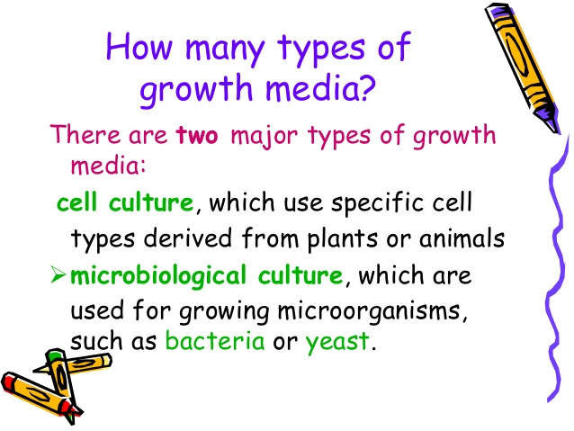

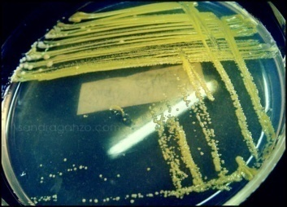
Pure culture :culture medium containing the growth
of single species of bacteria and we can preserve it by
1-Cooling 2-Freezing 3-Lyophilization(Freeze drying)

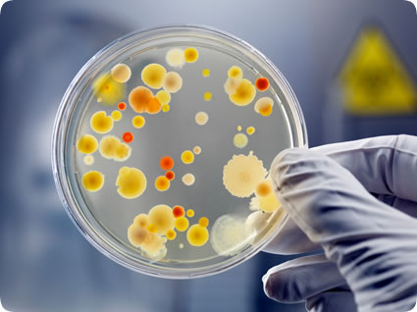
Mixed culture : culture medium containing the growth
of two or more species of bacteria i

Kinds of culture media

Culture media can be divided according to
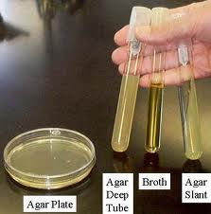
1-Their consistency
a-Solid media 2% agar

b-Semisolid media 1% agar

c-Liquid media 0% agar

Agar
Is a complex carbohydrate extracted from sea algae called Gelidium ,used in preparing culture media as solidifying agent because of its characteristics which are :
1-Its melting properties, melt at 90-100C˚ and solidify at 42C˚.
2-It has no nutritive value for majority of bacteria.

2-Their uses and contents
Natural media(non-synthetic)
Media contain natural material rich with vitamins and their structure and concentration are not defined such milk and blood
Defined media (synthetic media)
Medium contain chemical materials their structure and concentration exactly defined
Semi –synthetic media
Media contain natural material as well as chemical materials
Living media medium contain living tissue used to culturing viruses and cancer cell
Routine Laboratory Media
1. Basal media. Basal media are those that may be used for growth (culture) of bacteria that do not need enrichment of the media. Examples: Nutrient broth, nutrient agar and peptone water. Staphylococcus and Enterobacteriaceae grow in these media.
2. Enriched media The media are enriched usually by adding blood, serum or egg. Examples: Enriched media are blood agar and Lowenstein-Jensen media. Streptococci grow in blood agar media.
3. Selective media. These media favor the growth of a particular bacterium by inhibiting the growth of undesired bacteria and allowing growth of desirable bacteria. Examples: MacConkey agar, contain crystal violate that inhibit G^{+ve}.

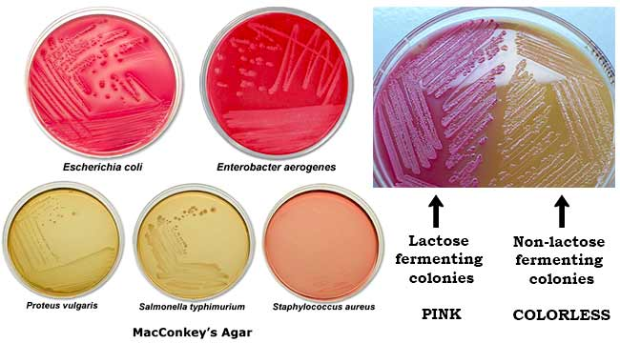
4. Differential media (Indicator). An indicator is included in the medium. A particular organism causes change in the indicator, e.g. MacConkey agar are differential media (contain lactose sugar and neutral red).

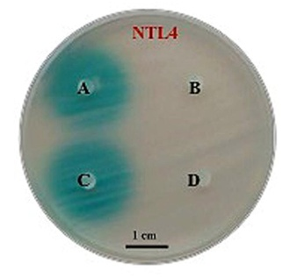
5. Transport media. These media are used when cannot be cultured soon after collection. Examples: Cary-Blair medium, Amies medium, Stuart medium.
6. Storage media. Media used for storing the bacteria for a long period of time. Examples: Egg saline medium, chalk cooked meat broth.

7-Assay medium Medium used to assay the production
amount of some material in bacteria

8-Enumeration media that used to calculate the number
of bacteria in water ,soil and food sample

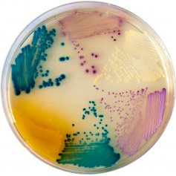
9-Characterization media that used to characterize and
recognize type of bacteria

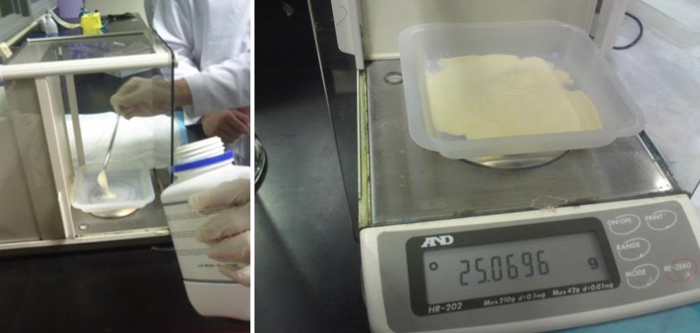
Preparation of culture media
1-Weightining the medium ingredients according
to the direction written on its container.

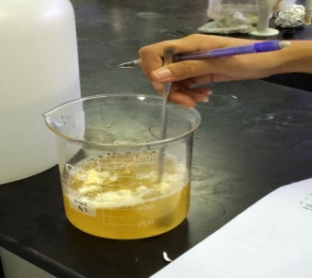
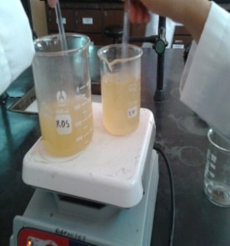
2-Dissolve with little amount of D.W. then
complete the volume to the volume you
want and may be need using heating and
stirrer for complete dissolving.

3-Check pH .

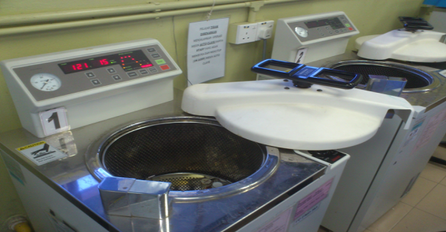
4-Dispensing the medium in to test tube by pipette.

5-Sterilization by autoclave.

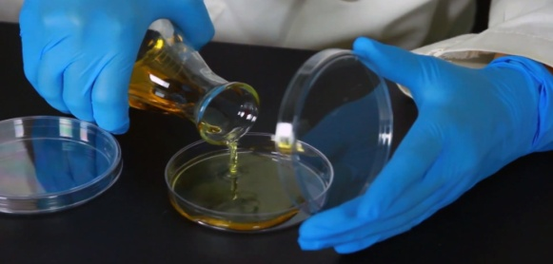
6-Dispensed agar medium into petri dish when the
heat reach to 45.

EX: prepare 500ml of N.A. medium if the direction
on container wrote 8gm/liter ?

gm ml
8 1000
x 500
x=8 * 500/1000 = 4 gm of media dissolve in little amount
Of D.W. then complete the volume to 500 ml then autoclaved
and poured in plates

Method of pouring the media in plate

The sterile plates should be on the table near the burner then
Cooling the solid medium to 45C˚ to avoid solidify it and to
avoid forming of drop on the cover of plates
Remove the cover (or cotton plug) and sterile the upper part by
burner
Remove the cover of plate near the burner and pouring the
medium and close the cover of plate
Moving the plate on table 5 times in two direction to distribute
the media equally in plate.

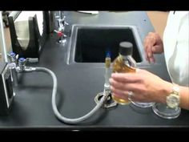

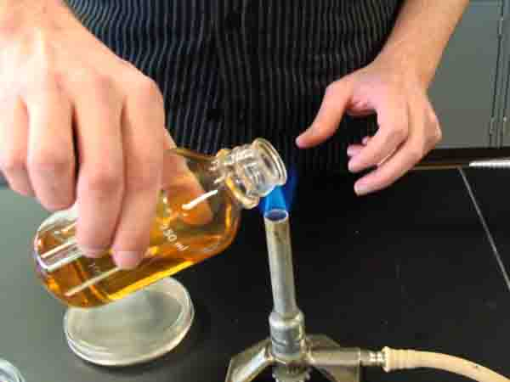
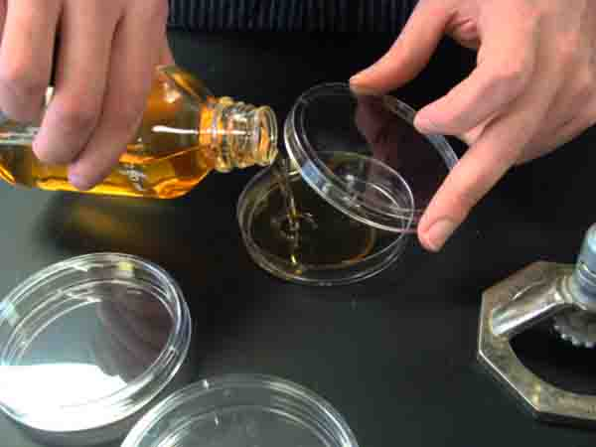

Sterility test
This test mean putting the flasks tubes and plates which contain sterile media before using in incubator at 37C for 24 hr. to ensure that there is no contamination while preparing and pouring the media

