Lab 1

Orientation microbiology lab (Tools and Equipment)

Prepared by

M.SC Hawraa D.salman

Lab-1-

Medical Microbiology classified into:
- Bacteriology is Study of bacteria
- Mycology is study of fungi
- Virology is study of viruses
- Parasitology is study of protozoan & helminthes
5- Immunology is study of resistance to disease

Tools and Equipment
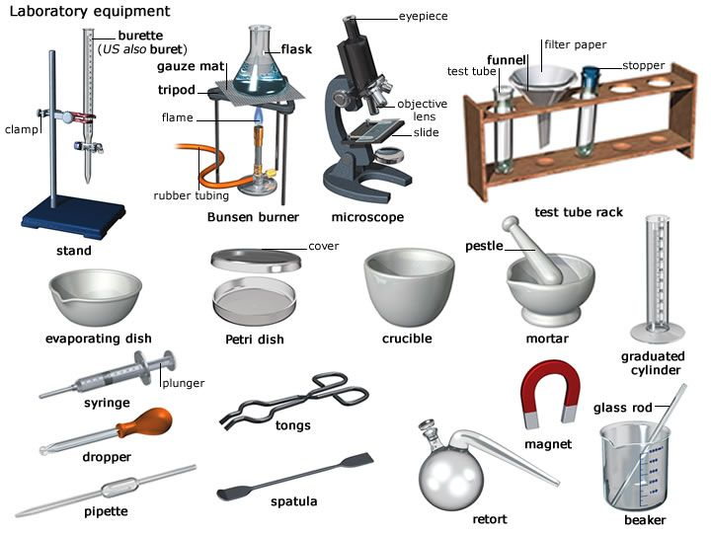

Tools
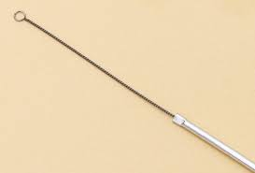
1-Loop
The loop is used in the cultivation of microbes on plates by
Transferring inoculums for streaking. Touching a broth or
a culture plate will gather enough microbes (0.01ml) for
Inoculation. The inoculation loop is sterilized with flame or another heat source.
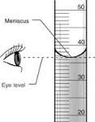
2-Can
Used for preserve the pipette from any contamination, sterilized with pipettes by autoclave

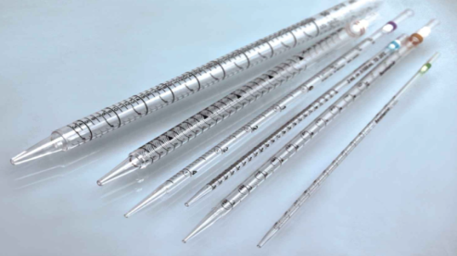
3-Pipette

Used for transfer of cultured and uncultured broth from tube or flask to other and placed in can sterilized by autoclave inside the can.

4-Spreader (L-shape)
Used for spreading bacterial cell on surface of solid medium in petriplate ,before using placed in alcohol and then sterilized by flame of burner.

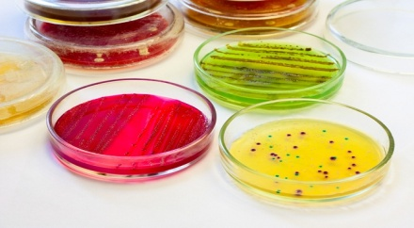
5-Petri-Dish(Petri-plate)
Used for place the solid medium in it, glass petri-dish used for many times and sterilized by oven or autoclave ,while sterilized plastic plates used for one time.

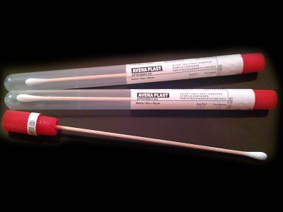
6-Swab
Used for swabbing bacterial cells on the surface of solid medium in Petri plate, must be placed in test tube and sterilized by autoclave, it used for one time.

7-Test tube
Used to place the liquid or solid or semisolid medium for stabbing or placed as slant for culture of bacteria ,it sterilized by autoclave.

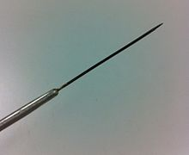
8-Needle
Used for transfer of bacterial cells to a solid medium or semi-solid medium by stabbing, sterilized by the flame of burner before and after use.

9-Slide
Used for examination of bacterial smear under microscope, it used for one time.

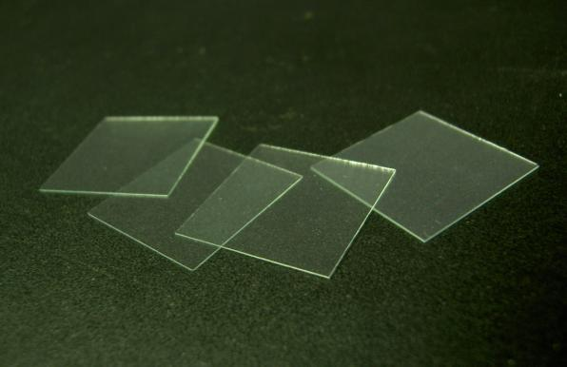
10-Cover-Slips
Placed on the slide, the bacterial smear may be between the cover and the slide, it used for one time.

11-Flask
Used for place cultured and uncultured broth in it ,
sterilized after plugs with cotton by autoclave.

12-Cotton plugs
A piece of coiled cotton used to close the upper part of flasks and tubes.

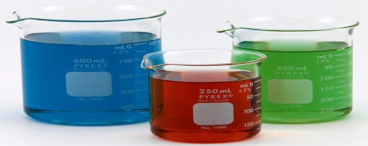
13-Beaker
Used for graduated the volume of liquids. Sterilized by oven.

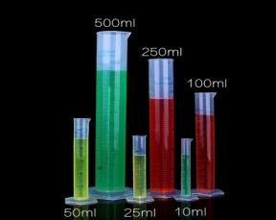
14-Cylinder(Graduated Cylinder)
Used for graduated the volume of liquids, sterilized by oven.

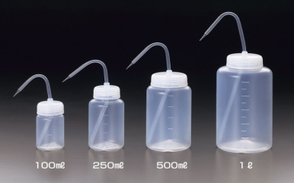
15-Washing bottle
Used to fill with liquid (specially distilled water)for washing
and homogenizing the glass wares and washing the slide
during staining , don’t need sterilization.

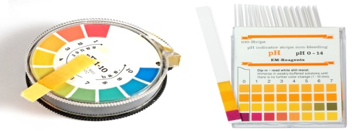

16-pH paper
Used to know the pH of the medium or any liquids

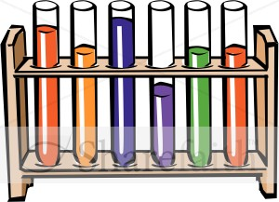
17-Rack
May be wooden, metallic or plastic used to stand and hold the tube.

18-Burner
May be gaseous or alcoholic , used for sterilized the loop , needle
and other metallic tools by flame (dry heat sterilization).

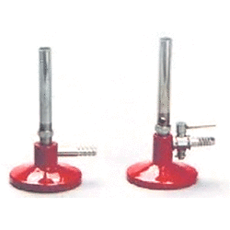
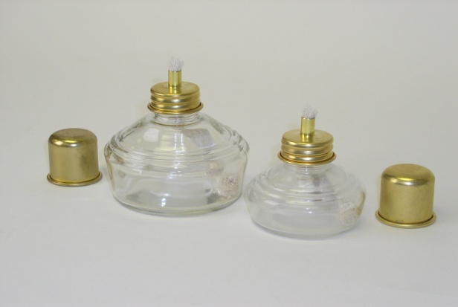

Equipments
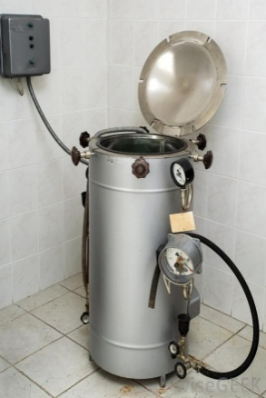
1-Autoclave
Wet heat sterilization= death by protein denaturation
It’s an equipment with:
High temperature (121C˚)
High pressure 1 atm(15 pound/inch²) used to sterilize media
(With sugar for 10min)
(Uncultured media for 15min),
(Cultured media and contaminated glass wares for 30 min)

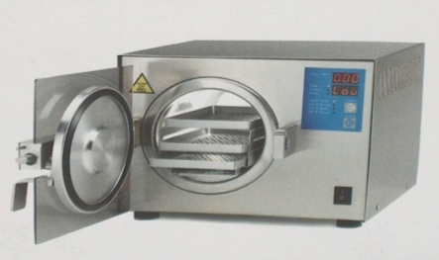
2-Oven
Dry heat sterilization=death by oxidation
Equipment with high temperature only (180C˚) for (90 min)
used to sterilized some of metallic tools and glass wares

3-Incubator
Is a device used to grow and maintain microbiological cultures or cell
cultures. The incubator maintains optimal temperature ,humidity and
other conditions such as the carbon dioxide (CO2) and oxygen content
of the atmosphere inside
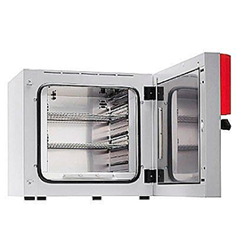

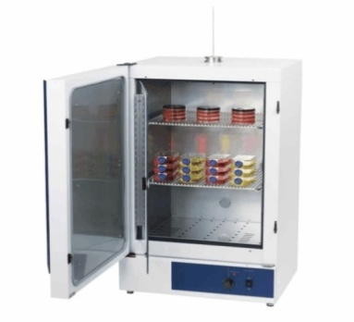

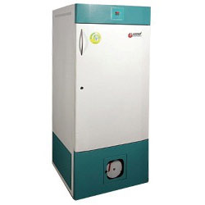
4-Refrigerator
Used to maintain the sterilized media and broth when not
used to avoid the contamination , and also to preserve the
bacterial culture for long time by preventing the growth at 4C˚.

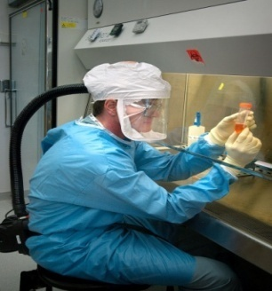
5-Biosafety cabinet (BSC)
Also called a biological safety cabinet or microbiological safety cabinet is aenclosed,ventilated laboratory workspace for safely working with materials contaminated with (or potentially contaminated with) pathogens

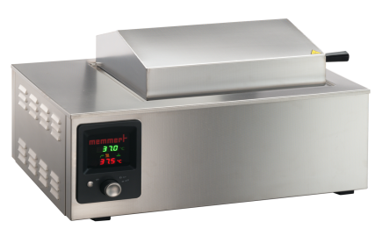
6-Waterbath
Is laboratory equipment made from a container filled with heated water. It is used to incubate samples in water at a constant temperature over a long period of time

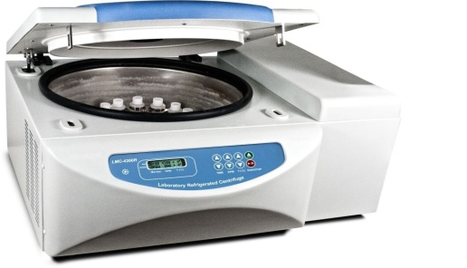
7-Centrifuge

A machine with a rapidly rotating container that applies
Centrifugal force to its contents.

